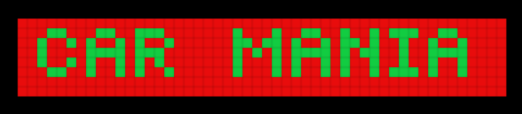

Car Mania

Instruction: Use up button to move forward use left right button to turn left and right use down button to move backward. And try to avoid bush and walls, Have fun.